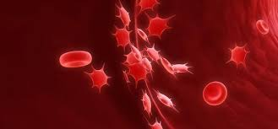
Subject: Biology Teacher: Mgr. Anna Demčáková
Class: III.A Topic: Circulatory system in humans
- Read and complete the text with the correct words from wordlist below
Wordlist: blood, capillaries, cardiovascular, cells, chamber, fluid, arteries, heart, organ, veins
The circulatory system, also called the _________________ system, is an organ system that permits _________ to circulate and transport nutrients, oxygen, carbon dioxide, hormones, and blood __________ to and from the cells in the body. It consists of the blood, the blood vessels and the hearth.
Blood is a bodily ______ in humans and other animals that delivers necessary substances such as nutrients and oxygen to the cells and transport metabolic waste products away from those same cells.
The __________ vessels are the part of the circulatory system that transports blood throughout the human body. There are three major types of blood vessels: the _________, which carry the blood away from the hearth, the ________________, which enable the actual exchange of water and chemicals between the blood and the tissues, and _____, which carry blood from the _____________ back toward the heart.
The heart is a muscular ___________ in humans and other animals, which pumps blood through the blood vessels. It is divided into two parts, left and right sides. Each side of the heart has two __________ .

VOCABULARY:

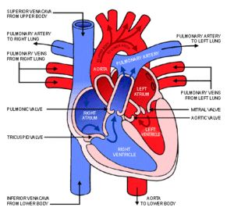
blood – krv
heart - srdce
aorta - srdcovnica
pulmonary - pľúcnica
pulmonary veins - pľúcne žily
vessels - cievy
veins - žily
arteries - tepny
capillaries - vlásočnice
blood circulation - krvný obeh
right atrium - pravá predsieň
left atrium - ľavá predsieň
right ventricle - pravá komora
left ventricle - ľavá komora
tricuspid valve - ľavá komora
mitral valve - dvojcípa chlopňa
red blood cells - červené krvinky
white blood cells - biele krvinky
platelets - krvné doštičky
coagulation - zrážanie krvi

- Match the words from in the text (1–5) to the definitions (A-E)

1 ______ attack A the blood vessels that carries blood from the heart to the rest of the body

2 ______ valve B a muscular organ which pumps blood through the blood vessels

3 ______ bleeding C the smallest type of blood vessels with a wall that is only one cell thick

4 ______ system D a bodily fluid in humans and other animals which colour is red

5 ______ clotting E the blood vessels that carries blood towards the heart

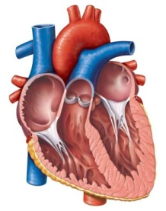
3. Look at the diagram and put these labels in the correct place

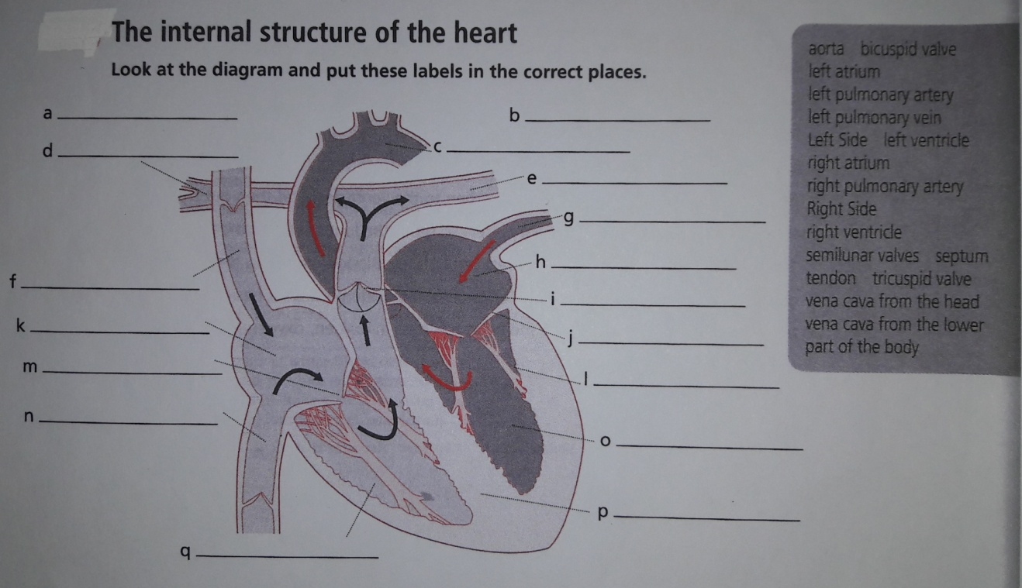

4. Working in groups of five– snake
Take one card from the set of the cards. Read a definitions from one of your cards and put it in the middle of the table. Match the word on the table to definition from your card. Make the snake.
(Cards see in the apendix)

- True/false statements
- The blood is pumped away from the heart to the lungs and returned, oxygenated, into the right side of the heart.
- The deoxygenate blood comes to the lungs, where CO2 is released from the blood, and oxygen is absorbed.
- The oxygenated blood is transported away from the herat to the rest of the body.
- The oxygen-depleted blood from the body returns back to the left side of the heart.
Appendix
Erythrocyte | The pale yellow liquid, component of blood
White blood cell | A blood cell that contains haemoglobine and gives the blood its colour
Platelet | A type of blood cell that protects the body against infection and produce antibodies
Haemoglobin | A small piece of a cell in the blood that helps the blood to clot
Blood plasma | A protein in red blood cells that carries oxygen from the lungs to all parts of the body

